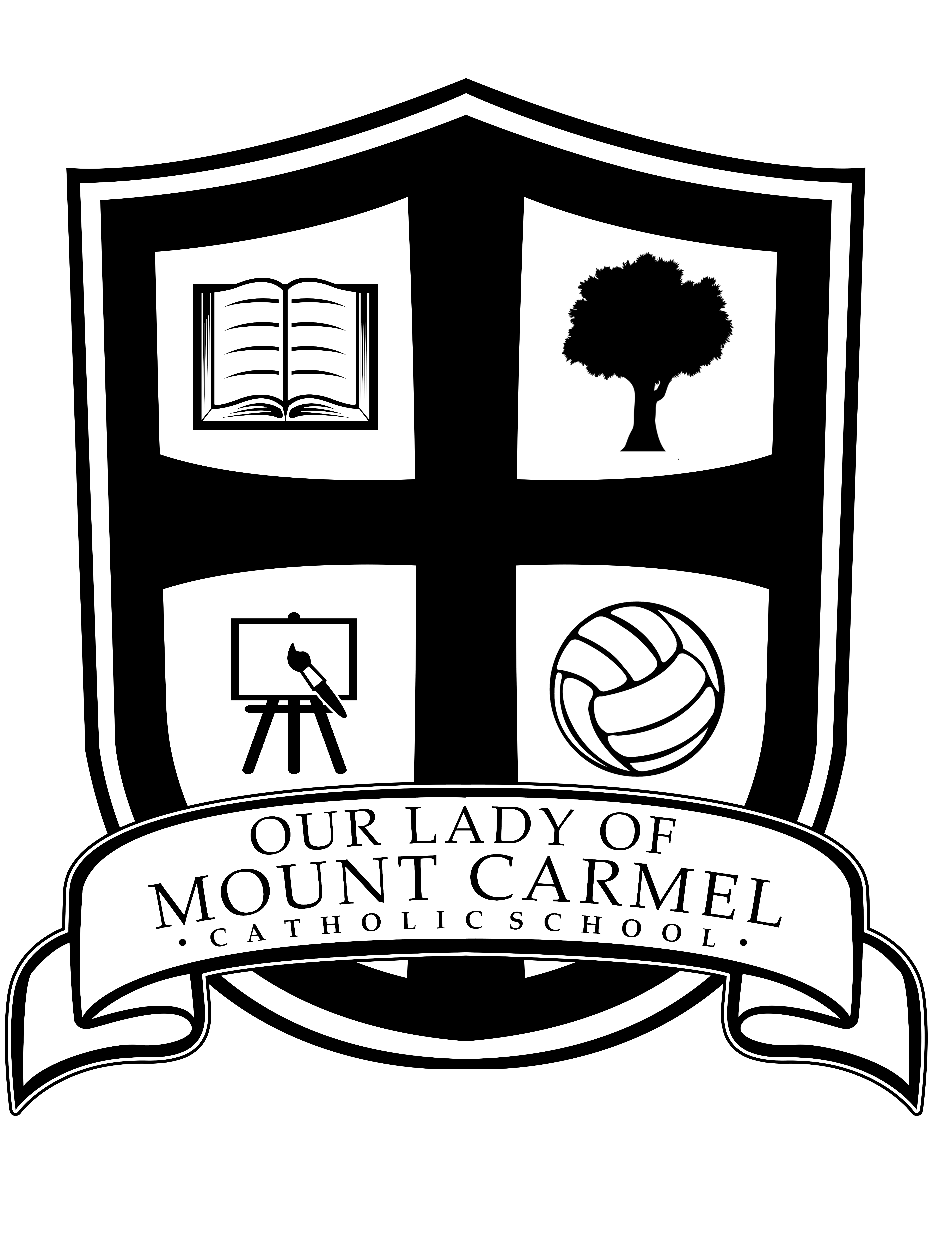

Year-end Newsletter
June 24th, 2019
Prayer at the end of a school year
As the end of the school year draws near, we offer our thanks and our praise to God for all of the joy and blessings that we have experienced throughout the year, and for sustaining us and walking with us through the successes and challenges that we have faced. As we move into the summer months, let us invite God to continue to be with us as we journey forth through the changes and blessings that the summer months will bring.

Staffing Update
As we begin to prepare for our return to school in September, and in addition to staff movement communicated in our June Newsletter, please note that Ms. Sandra Fragoso has been appointed Principal at St. Thomas More Catholic School, effective September 2019. We wish her the very best in her new assignment as Principal. We welcome Ms. Louise Trudeau to Our Lady of Mount Carmel as Vice Principal. In addition, we say farewell to Mrs. Hazel who will be transferring to St. Patrick- Harrowsmith. We wish her well at her new school.

School Council
We would like to thank our OLMC School Council for their support of student learning and achievement during the 2018-2019 school year. We are grateful to our School Council as they continue work on planning and hosting fundraising initiatives to support the purchase of many resources and materials for our students. In particular, we say “Thank you” to School Council this year for purchasing and installing the picnic tables and benches on the yard. Thank you for your ongoing support of our students!

Hot Dog Day- Tuesday, June 25, 2019
Please be reminded that School Council is providing a Hot Dog Lunch for all students in Kindergarten to Grade 8. Parents are asked to supplement lunches and snacks as needed. Thank you to School Council for their generosity!

Summer Play Day- Tuesday, June 25, 2019 for Grades 1-8
A Summer Play Day for students in Grades 1-8 is planned for the morning of Tuesday, June 25th, 2019, weather permitting. Students are reminded to dress for participation in a morning of outdoor activities. Students will receive freezies at the rest station. Thank you to staff for co-ordinating outdoor games!

Athletic Assembly
Students in Grade 3-8 will gather in the Gym in the afternoon on Tuesday, June 25th to recognize students who have excelled in athletic activities this year.

Year-end Prayer Celebration- Wednesday, June 26, 2019
As the school year draws to a close, we will gather to give thanks in prayer for another year of learning and growing! The prayer celebration will take place in the Gym on Wednesday, June 26th at 9:15 for students in Kindergarten to Grade 3 and at 9:45 for students in Grades 4-8.

Talent Show- Thursday, June 27, 2019
Students have been practicing to showcase their talents during two Talent Shows that will take place on Thursday, June 27th, 2019 at 9:15 and then repeated at 10:45 in the Gym. We look forward to up and coming OLMC entertainment!

As part of the Talent Show this year, Grade 5 students from Mrs. Lake’s Class have organized and are co-ordinating a food drive for local families in our community. When asked how they were inspired to host the food drive, they wrote: “We were reading in social studies about people in Canada who didn’t have food. We wanted to help. So we had an idea that we could help in our community by getting students to bring in a small food donation or a non-perishable food item to the Talent Show on Thursday, June 27th. All donations will be given to the Partners in Mission Food Bank in Kingston. Thank you for helping!” Students may bring in donations on Monday to Thursday during the last week. Again, thank you for your participation in our Talent Show Food Drive to support our community!

Medication Pick up
If your child has medication at the school Office, parents are asked to come by the school to pick up medication as there are no provisions for storage of medication over the summer.

Library Book Return
We are recalling all Library books that are still at home to make their way back to school. Mrs. Clarke in the Learning Commons will be receiving returned library books all week. Please help us by searching for and returning all OLMC books. Thank you!

Paid Lunch-time Supervisors Needed
We are currently seeking paid lunch-time supervisors to work one hour each day from 11:50-12:50 p.m. in September. As a paid lunch-time supervisor, you are responsible for supervising students while they are eating their lunch in the classroom and supervising students on the yard at lunch recesses. Interested candidates are invited to contact the school. Candidates should possess or be willing to acquire a current Criminal Background Check.

First Day of School Procedures
On the morning of Tuesday, September 3rd, Primary students in Grades 1-3 should gather at the Primary Play Structure, where teachers will have class lists on signs to gather their students. Class lists for students in Grades 4-8 will be posted on the recess doors of the portapacks. Junior Kindergarten students will receive a letter from their Kindergarten teacher during the week of August 26th. Please note that the number of teachers on staff is determined by the number of students. There will continue to be straight and split grades again, as well as shared classes in the French Immersion Program. All class lists and staff assignments will be finalized at the end of August. Thank you for your patience and understanding.

Welcome Back BBQ
While we wish everyone a break from school routines and a restful summer, our Welcome Back BBQ is scheduled to take place on Thursday, September 19, 2019 from 5:30-7:00 p.m.

We wish all of our students and their families a safe and restful summer!

